Time Series Plots of Monthly Linearly Interpolated Data
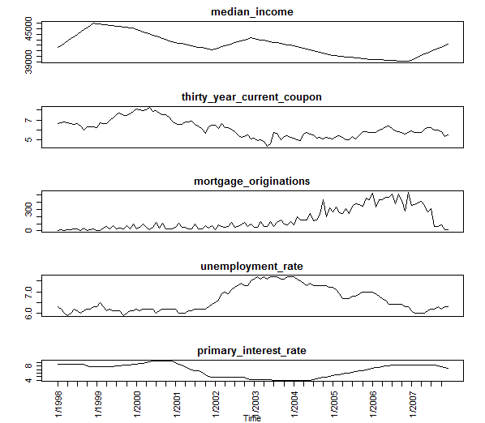
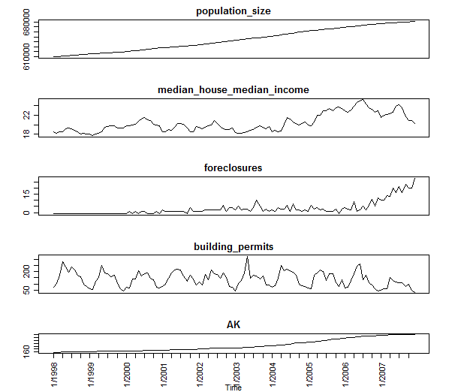

Time Series Plots of Monthly Linearly Interpolated Data Simple Returns
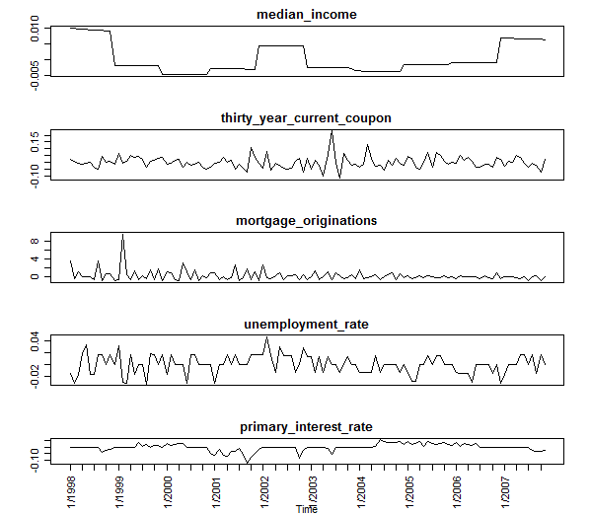
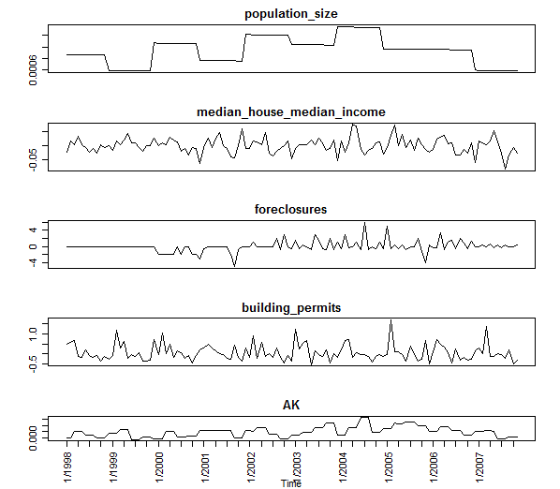
ACF/CCF of Monthly Linearly Interpolated Data
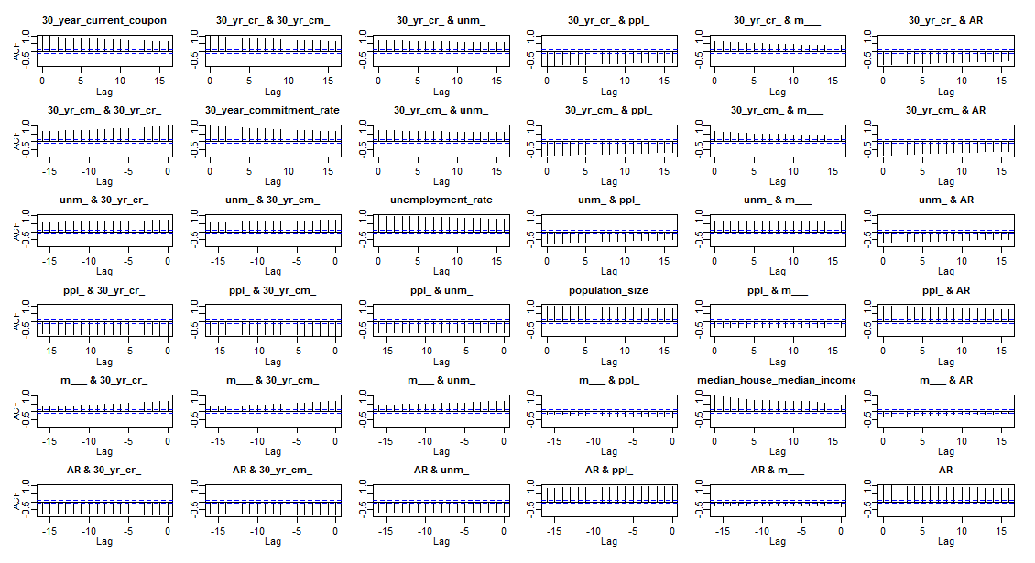

ACF/CCF of Monthly Linearly Interpolated Data-Simple Returns
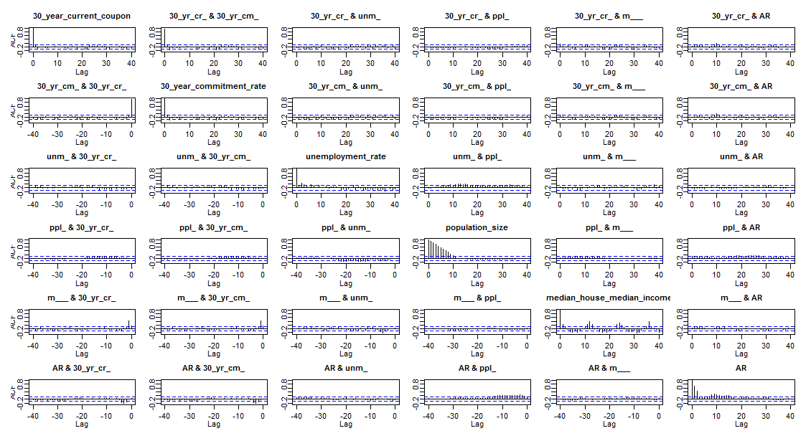

Scatterplot of Monthly Linearly Interpolated Data
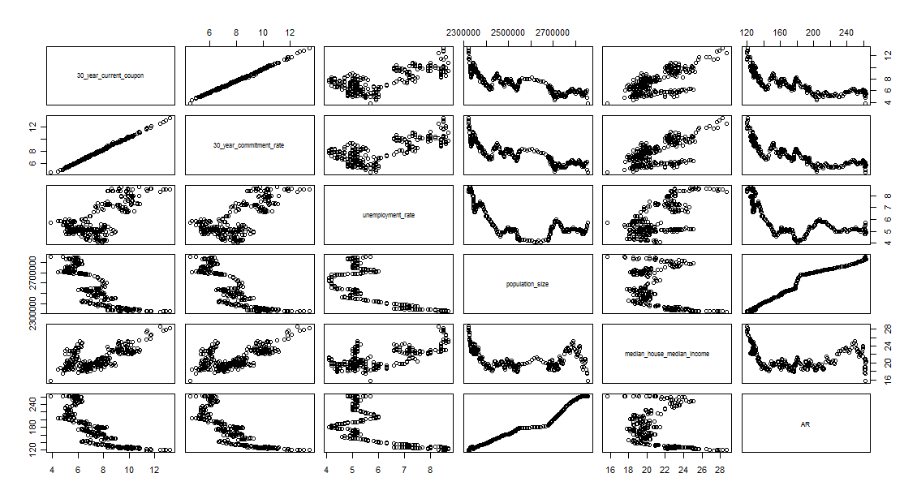

Scatterplot of Monthly Linearly Interpolated Data-Simple Returns
